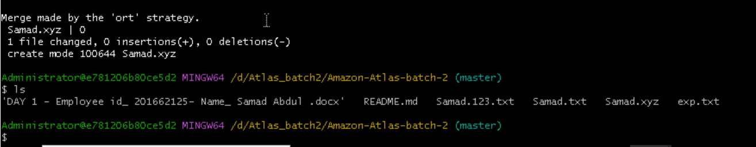

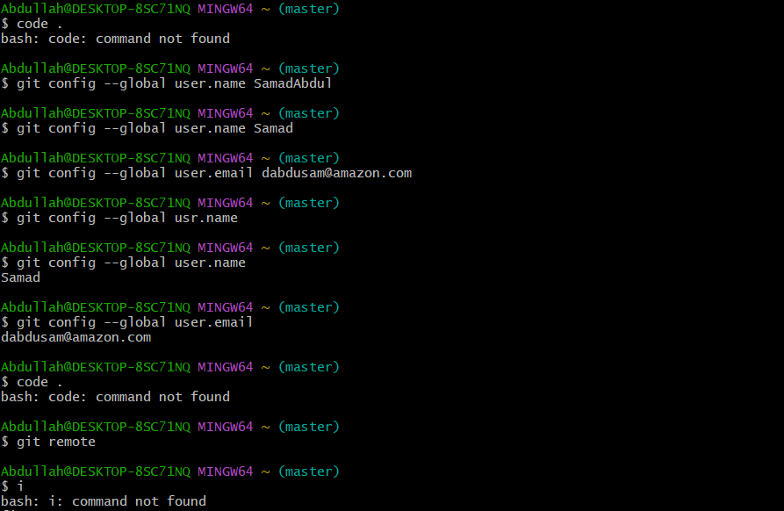

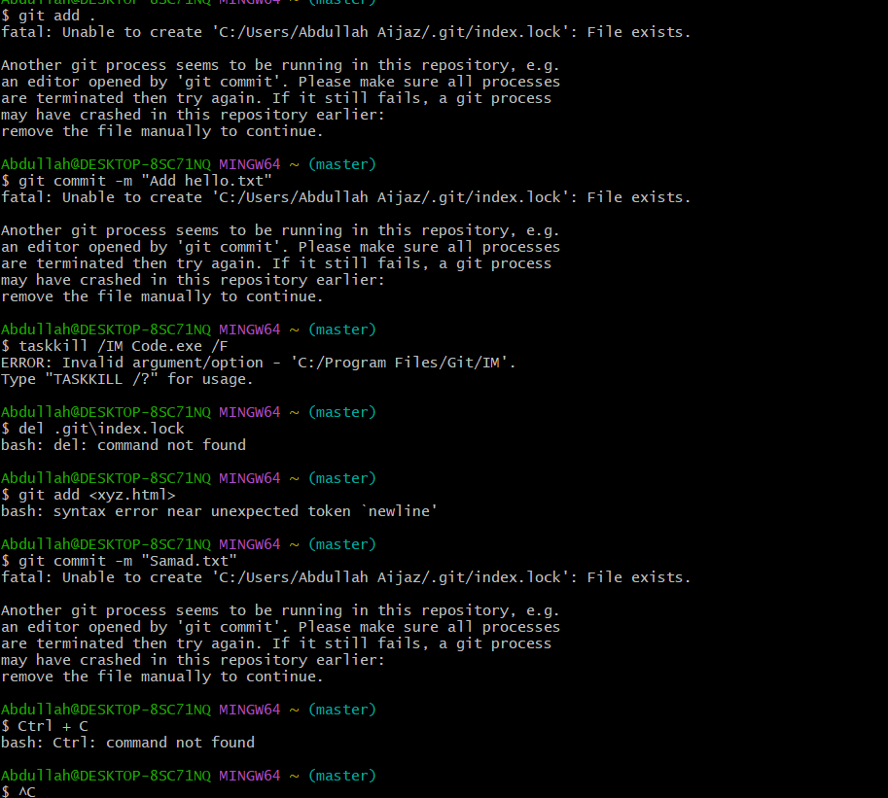

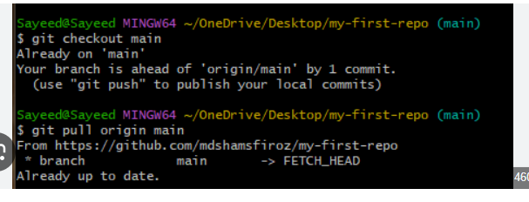

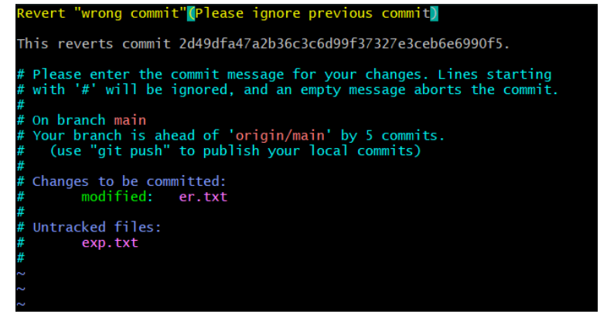

**Removing Untracked File :**

git clean -n (ask for delete yes or no)  
git clean -f (forcefully)

**Tags :**

It is used to gives meaningful names to a specific version in the repository.

git tag -a <samad.txt> -m <samad file> <commit-id>  
  
 To see the list of tags  
git tag  
  
 To see particular commit content by using tag  
git show <samad.txt>  
  
 To delete a tag  
git tag -d <samad.txt>